- I have a book. It´s........ book.
You have a girlfriend. It´s ......... girlfriend.
She has a pet. It´s ......... pet.
He has a car. It´s ......... car.
We have a house. It´s ......... house.
They have a big family. It´s ......... family.

- She is ................................ (80).
I read a book ...........................(50) Shades of Grey.
My address is Športová ................................. (29).
At the airport look for the Gate ...................................(43).

- Name: Lucy
From: Spain
Address: American St. 17
Age: 35
Marital status: single/married/divorced
Job: shop assistant
Tel. number: 0916 566 358
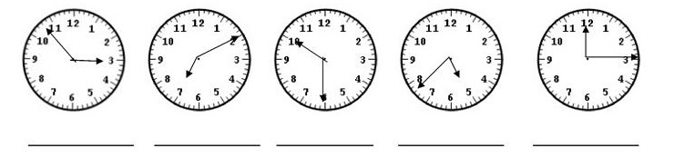

- Plural:
key ..................... card ........................... money ............................. child............................
man.................... person........................ woman.............................. pen.............................
orange................ sandwich.................... watch................................ desk.............................

- Where is your........now?
car ................................................................... glasses...........................................................
English book .................................................... novel.............................................................
bag................................................................... feet................................................................
- In the shop:
otvorené ....................................... shoes:
zatvorené ....................................... colour:
ťahaj ....................................... size:
tlač ....................................... price:
- My breakfast: ............................................................................................................................................................................................................................................................................................................
Čo ješ / piješ na raňajky?
Mám rád...
Nemám rád.....
Máš rád...........

